“ArduinoCart”

Arduino Bluetooth Controlled Car

Documentation

Developed by:

Veselin Inzov and Hristo Shirov

2020

Contents

About..................................................................................... 3

List of components................................................................ 4

Block diagram........................................................................ 5

Electrical diagram.................................................................. 6

Source code and functionality............................................... 7

Summary............................................................................... 9

About

“ArduinoCart” is a four-wheel drive robot powered by 4 separate DC motors. It can be controlled by the user using a Bluetooth equipped device e.g. an android smartphone.

List of components

1. Arduino Uno
2. Bluetooth HC-05 module
3. DEEK-ROBOT Motor Shield L293D
4. DC motors x 4
5. 9V Li-ion Battery x 2
6. Chassis and 4 wheels
7. Jumper wires

Block Diagram

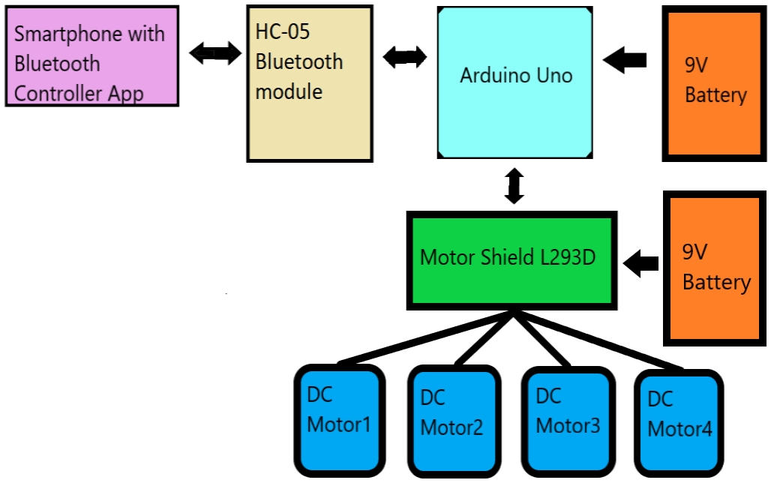

Electrical diagram

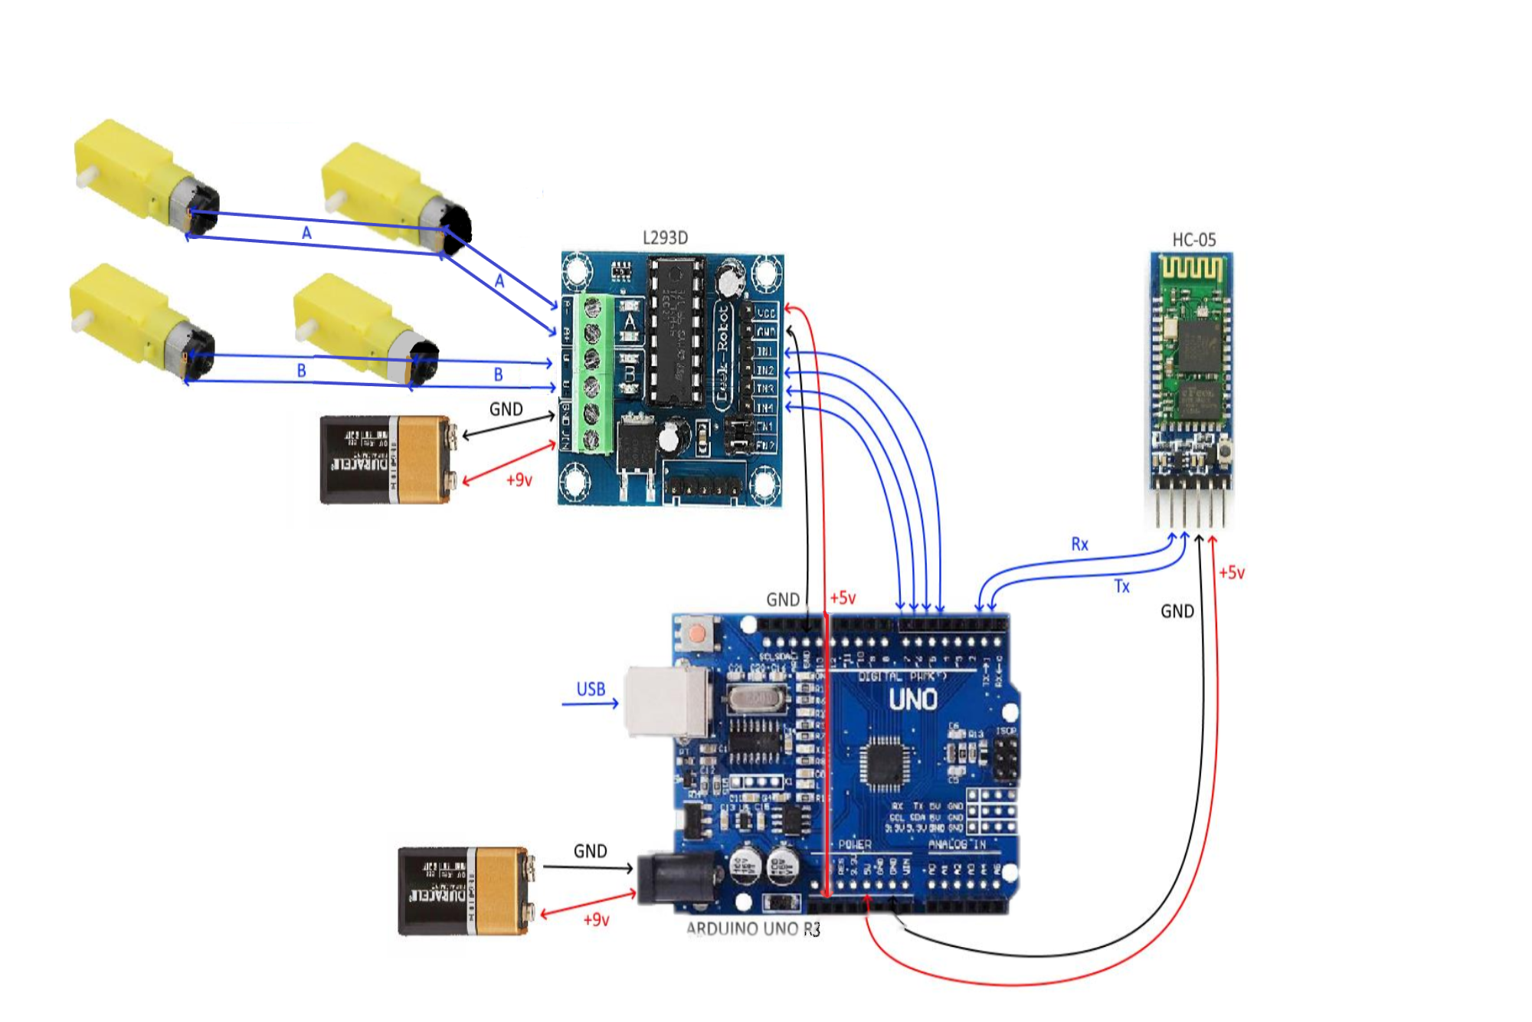

Source code and functionality

String command;

int in1 = 4;

int in2 = 5;

int in3 = 6;

int in4 = 7;

void setup() {

pinMode(in1, OUTPUT); **//left motors forward**

pinMode(in2, OUTPUT); **//left motors reverse**

pinMode(in3, OUTPUT);  **//right motors forward**

pinMode(in4, OUTPUT); **//right motors reverse**

Serial.begin(9600);

}

void loop() {

if(Serial.available()) {

command = Serial.read();

Serial.println(command);

}

**In the next lines we read the commands sent from the user.**

if (command == “FORWARD”) { **//move forward(all motors rotate in forward direction)**

digitalWrite(in1,HIGH);

digitalWrite(in3,HIGH);

}

else if (command == "BACKWARD") { /**/move reverse (all motors rotate in reverse direction)**

digitalWrite(in2,HIGH);

digitalWrite(in4,HIGH);

}

else if (command == "LEFT") { **//turn left (right side motors rotate in forward direction, left side motors doesn't rotate)**

digitalWrite(in3,HIGH);

}

else if (command == "RIGHT") { **//turn right (left side motors rotate in forward direction, right side motors doesn't rotate)**

digitalWrite(in1,HIGH);

}

else if (command == "STOP") { **//STOP (all motors stop)**

digitalWrite(in1,LOW);

digitalWrite(in2,LOW);

digitalWrite(in3,LOW);

digitalWrite(in4,LOW);

}

delay(100);

}

**This is the code for the android application.**

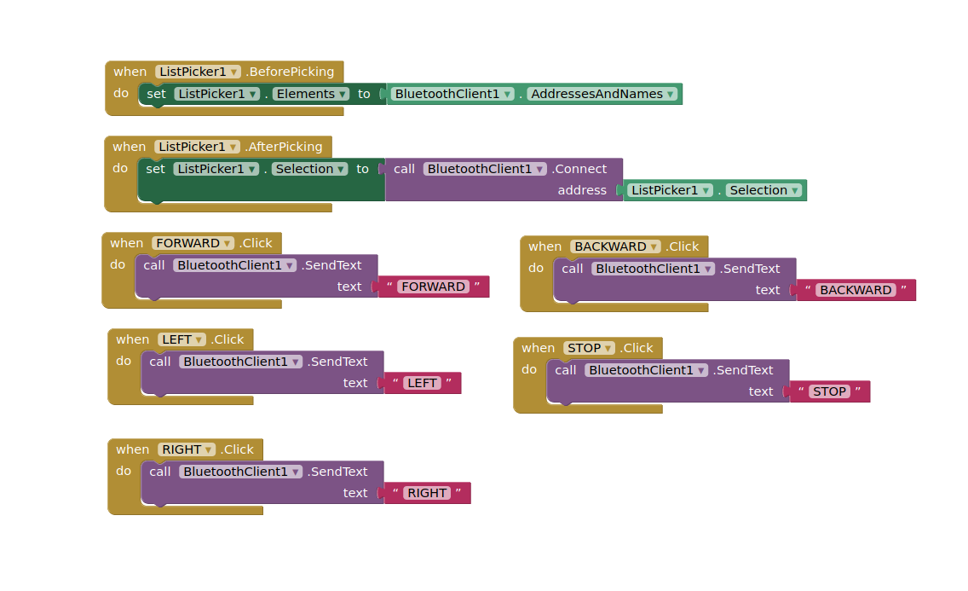

Summary

We worked hard, putting everything together and making it work. Due to time restraints the project wasn’t as ambitious as we would normally like.

Like any beginner project this one has some cons:

1. The user has to download an android app to be able to control the robot.
2. The robot uses all 4 motors to move, which means it needs a lot of power.

Things we can add:

1. On/Off button to prevent power loss.
2. More stable body structure(chassis).
3. Better battery(rechargeable).
4. LED indication.
5. Ultrasonic sensor to prevent possible front crashes.